EXPT. NO: 6 | DECISION MAKING CONSTRUCTS
DATE:8.1.2020 | DECISION MAKING CONSTRUCTS
Aim:
To write a C program for the following
- Find the biggest of two numbers
- Check whether the given year is leap year or not
- Compute grade for given mark
1. Find the biggest of two numbers
Algorithm
- Start the program
- Read the values of num1, and um2
- IF num1>num2 THEN
- PRINT num1 is the biggest number
- ELSE
- PRINT num2 is the biggest number
- Stop the program
Flowchart
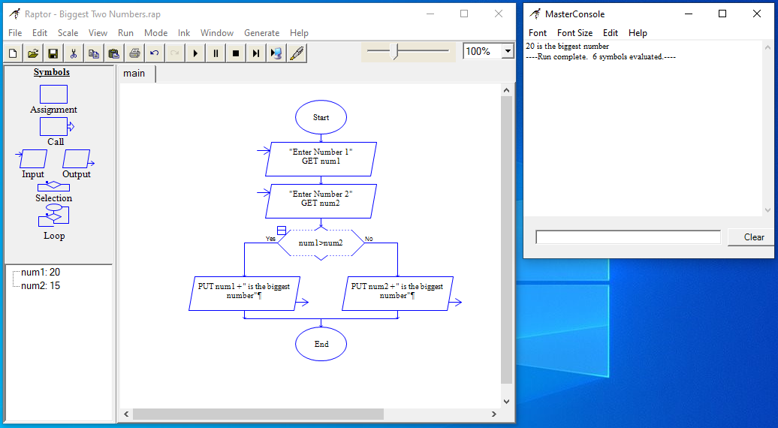
Program
#include <stdio.h>
int main()
{
int num1, num2;
printf("Enter the Value Of num1 and num2: ");
scanf("%d %d", &num1, &num2);
if(num1>num2) {
printf("%d is The Biggest Number", num1);
} else {
printf("%d is The Biggest Number", num2);
}
return 0;
}
Output
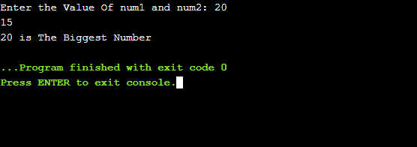2. Check whether the given year is leap year or not
Algorithm
- BEGIN
- READ The Value Of Year
- IF ((year%4 = = 0 AND year%100 != 0) OR (year%400 = = 0 )) THEN
- PRINT the given year is a leap year
- ELSE
- PRINT the given year is not a leap year
- END
Flowchart
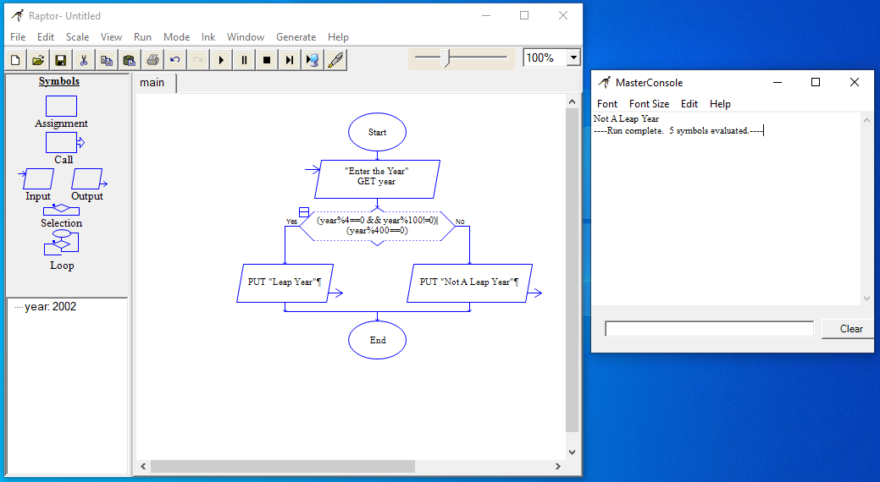
Program
#include <stdio.h>
int main()
{
int year;
printf("Enter the Year: ");
scanf("%d", &year);
if((year%4==0 && year%100!=0)||(year%400==0)) {
printf("Leap Year");
} else {
printf("Not A Leap Year");
}
return 0;
}
Output
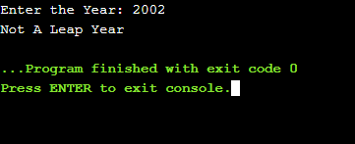

3. Compute grade for given mark
Algorithm
- BEGIN
- READ The Value Of mark
- IF (mark > 90) THEN
- PRINT “O” Grade
- ELSE IF (mark > 80) THEN
- PRINT “A+” Grade
- ELSE IF (mark > 70) THEN
- PRINT “A” Grade
- ELSE IF (mark > 60) THEN
- PRINT “B+” Grade
- ELSE IF (mark > +50) THEN
- PRINT “B” Grade
- ELSE
- PRINT “RA” Grade
- END

Flowchart
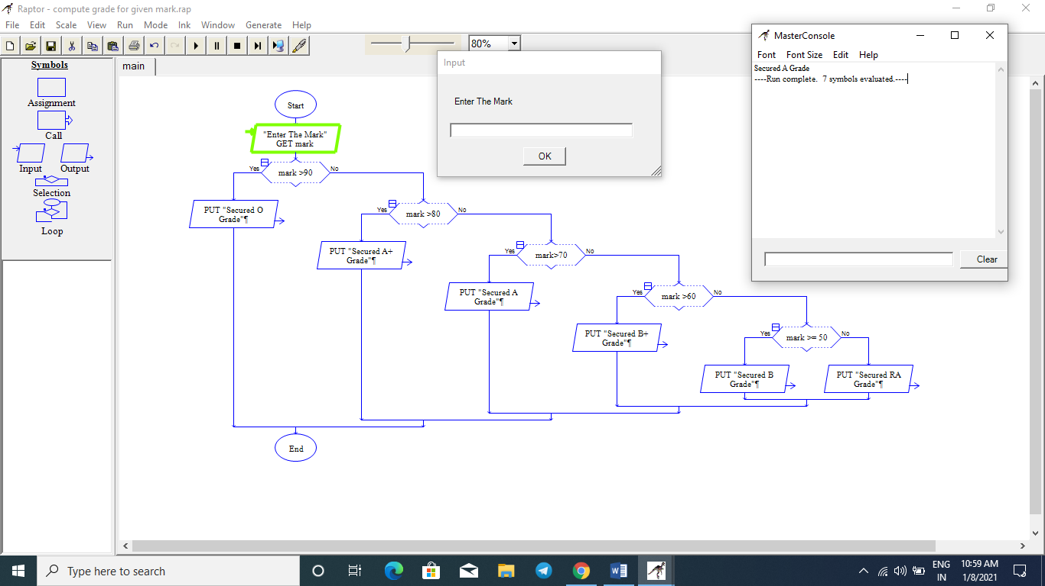

Program
#include <stdio.h>
int main()
{
int mark;
printf("Enter the Mark: ");
scanf("%d", &mark);
if (mark>90) {
printf("O Grade");
} else if (mark>80) {
printf("A+ Grade");
} else if (mark>70) {
printf("A Grade");
} else if (mark>60) {
printf("B+ Grade");
} else if (mark>=50) {
printf("B Grade");
} else {
printf("Secured RA Grade");
}
return 0;
}

Output
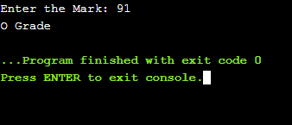
Result
Thus the C program was written and executed successfully for the following
- Find the biggest of two numbers
- Check whether the given year is leap year or not
- Compute grade for given mark

